**Brand narrative/ personality which makes Zara uniqu**e

Brand Personality means what the brand is when it becomes a person.

Zara’s brand personality is aggressive yet **calm**, **mature**, **confident**, **beautiful**, **well-kept**, **modest**, **unpretentious** and **low profile**.

To keep a strong position in the market, Zara spends a large amount of time and resources designing, planning and launching their collection in only four weeks.

The values for consumers were **customer orientation**, **professional quality**, and

**sustainability**. Inditex placed its customers at the heart of its business model, and

their satisfaction was the ultimate measure of the company’s performance. On its

brand page, Zara referred to the intimate relationship it had with its customers.

They have sought to meet the needs of customers by having Zara designers respond

to changing needs, respond to the latest trends and continuous customer feedback

to provide customers with new fashion ideas in the right place at the right time.

The men’s and women’s models were **youthful**, **modern**, and **exclusive**. Zara products highlight the **uniqueness** of the wearer. A Zara customer analysis from a psychographic standpoint shows that Zara customers are highly style conscious, tech savvy and value their unique identity. They want the latest fashions, but also want to express their individuality and enjoy a personalized shopping experience. The strong colors of the visual content also emphasized character, distinction, and modernity. The style of the messages for the core audience groups reflects Zara’s brand personality, which is passionate, curious, demanding, innovative, and proactive.

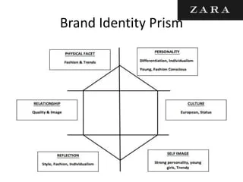

Credits : Slideshare